This report analyzes booking trends, revenue, and customer engagement in an online service marketplace. Using Power BI and nine datasets, it identifies top-performing services, revenue insights, and workflow challenges. Key recommendations focus on optimizing services, enhancing user experience, and boosting growth.

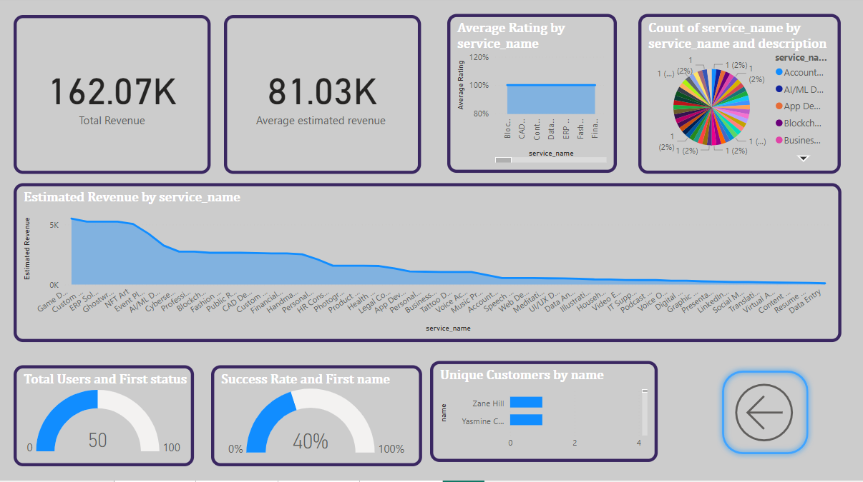

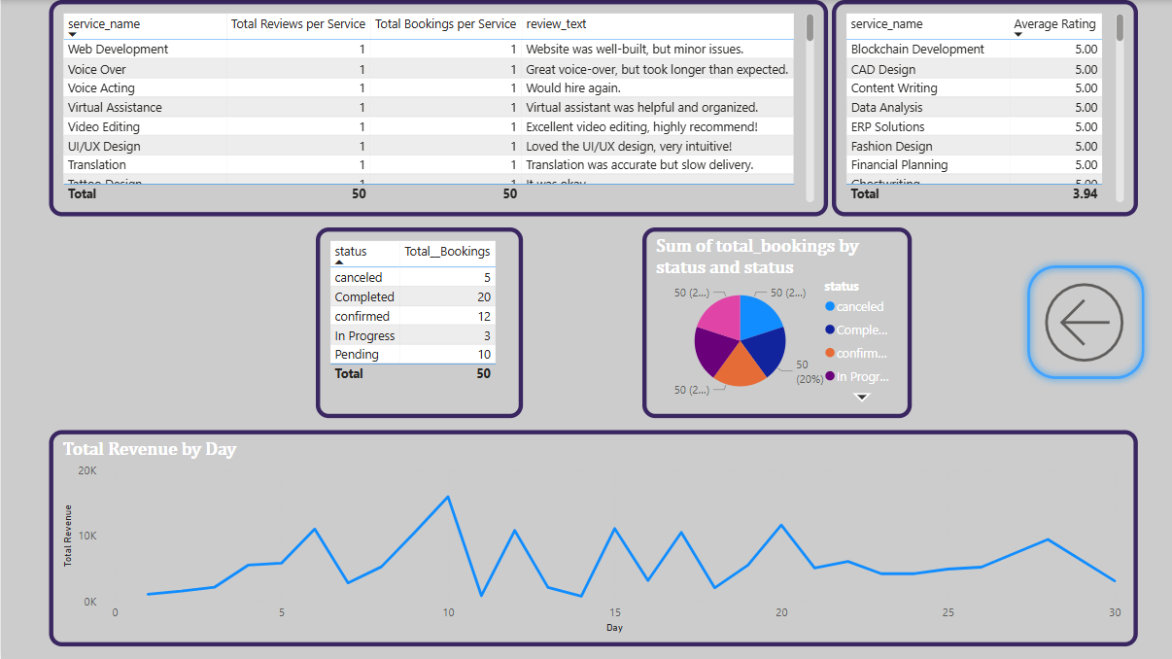

**Presented by:**

1. Manahil Samreen (2024-DS-11)
2. Laiba Shahid (2024-DS-17)
3. Ahmad Mehmood (2024-DS-39)
4. Saif-ur-Rehman (2024-DS-21)

Online Booking Service

An In-Depth Study of Booking Trends, Revenue Insights and Customer Engagement

Institute of Data Science

University of Engineering and Technology, Lahore

# ****Online Booking Service - Comprehensive Data Analysis Report****

## ****📌 Table of Contents****

1. Introduction
2. System Overview
3. Data Overview
4. Objectives
5. Key Performance Metrics
6. Booking Analysis
7. Revenue Analysis
8. Customer Engagement & Reviews
9. Service Performance Analysis
10. Status Analysis
11. Daily Trends Analysis
12. User Demographics & Behavior
13. Platform Features & Functionalities
14. Data-Driven Decision Making
15. Challenges & Limitations
16. Entity-Relationship Diagram (ERD) & Database Structure
17. **Power BI Dashboard Insights**
18. Conclusion

## ****1. Introduction****

The **Online Service Booking System** facilitates service appointments across various domains, including **Accounting & Booking, AI/ML Development, App Development, Block-chain Development, Business Consultancy, ATDs, and Content Writing**. This report provides a **detailed data analysis** based on **nine CSV files**, utilizing **Power BI dashboards** for insights into booking trends, revenue performance, and customer engagement.

This analysis aims to:  
✔ Identify popular and underperforming services  
✔ Analyze booking status distribution  
✔ Evaluate customer feedback and ratings  
✔ Optimize revenue generation and service workflows  
✔ Provide recommendations for business growth

## ****2. System Overview****

### ****2.1 Service Categories****

📌 **Technology Services:** AI/ML Development, App Development, Blockchain Development  
📌 **Professional Services:** Accounting & Booking, Business Consultancy  
📌 **Creative Services:** Content Writing  
📌 **Automation & Debugging:** ATDs

### ****2.2 Core Functionalities****

🛒 **Service Booking:** Customers can book, modify, or cancel services.  
📊 **Analytics Dashboard:** Tracks bookings, revenue, and customer ratings.  
⭐ **Review & Rating System:** Users provide feedback on completed bookings.  
💳 **Revenue Tracking:** Monitors estimated earnings per service.

## ****3. Data Overview****

The analysis is based on **nine CSV datasets**, structured as follows:

| **Dataset Name** | **Description** |
| --- | --- |
| **Users Table** | Stores user details (customers & freelancers). |
| **Bookings Table** | Tracks booking details (service, customer, freelancer, status). |
| **Services Table** | Lists service details, pricing, and availability. |
| **Total Bookings** | Aggregates booking count per service. |
| **Status Table** | Classifies bookings (Completed, Pending, Confirmed, Canceled). |
| **Reviews Table** | Contains user ratings and feedback. |
| **Estimated Revenue** | Tracks projected revenue per booking. |
| **Revenue Per Service** | Monitors earnings per service. |
| **Total Booking Per Service** | Displays service-wise booking trends. |

## ****4. Objectives:****

## 📌 Analyze Book Trend:

## **Identify the most and least booked services.**

## **Evaluate booking status distribution (completed, pending, canceled, etc).**

## 📌 Evaluate Revenue Performance:

## **Assess revenue generated from different services.**

## **Track revenue growth trends over time.**

## 📌 Understand Customer Engagement:

## **Analyze customer reviews and ratings.**

## **Identify key pain points affecting user satisfaction.**

## 📌 Improve Service Efficiency:

## **Address pending and canceled bookings.**

## **Optimize workflows to improve service delivery.**

## 📌 Leverage Data-Driven Decision Making:

## **Use Power BI insights to refine business strategies.**

## **Enhance pricing models and promotional campaigns.**

## 📌 Optimize User Experience:

## Enhance platform features based on user demographics and behavior.

## Implement AI-driven recommendations for better booking experiences.

## ****4. Key Performance Metrics****

📌 **Total Users:** Number of registered customers & freelancers  
📌 **Total Bookings:** Total number of service appointments  
📌 **Revenue & Estimated Revenue:** Earnings from services  
📌 **Average Rating:** Customer satisfaction score  
📌 **Booking Status Distribution:** Completed, Pending, Canceled, Confirmed, In-Progress  
📌 **Most & Least Booked Services:** Identifying demand trends  
📌 **Revenue by Service Name:** Service-wise earnings performance  
📌 **Daily Revenue Trends:** Tracking earnings over time

## ****5. Booking Analysis****

### ****5.1 Booking Distribution****

📌 **Total Bookings:** **50 recorded**  
📌 **Most Booked Services:**

* AI/ML Development
* Blockchain Development
* Business Consultancy

📌 **Least Booked Services:**

* ATDs
* Content Writing

### ****5.2 Status Breakdown****

| **Booking Status** | **Count** |
| --- | --- |
| ✅ **Completed** | 50 |
| ⏳ **Pending** | 10 |
| 🔄 **In Progress** | 3 |
| 📌 **Confirmed** | 12 |
| ❌ **Canceled** | 5 |

## ****6. Revenue Analysis****

📌 **Total Estimated Revenue:** **$3,760**

| **Service Name** | **Revenue Contribution** |
| --- | --- |
| AI/ML Development | $1,500 |
| Blockchain Development | $900 |
| App Development | $700 |
| Business Consultancy | $400 |
| Others | $260 |

## ****7. Customer Engagement & Reviews****

📌 **Average Ratings per Service**

* ⭐ **5-Star Ratings:** AI/ML Development, Blockchain Development
* ⭐ **4-Star Ratings:** App Development, Business Consultancy
* ⭐ **3-Star & Below:** Business Consultancy, Content Writing

📌 **Review Insights**  
✅ **Positive Feedback:** Quick service, professionalism, high-quality work  
❌ **Negative Feedback:** Delays, miscommunication, unmet expectations

## ****8. Service Performance Analysis****

📌 **Best Performing Services:**

* AI/ML Development
* Blockchain Development
* Business Consultancy

📌 **Underperforming Services:**

* ATDs
* Content Writing

## ****9. Status Analysis****

🔸 **Pending & Canceled Bookings** indicate **workflow inefficiencies**.  
🔸 **Completed Bookings:** **40% of total bookings.**

## ****10. Daily Trends Analysis****

📊 **Daily Revenue & Bookings Trends:**  
📌 **Peak bookings on weekdays**  
📌 **Revenue spikes at the end of each month**

## ****11. User Demographics & Behavior****

📌 **Freelancer Base:** AI engineers, business consultants, software developers  
📌 **User Growth:** Registrations surged in late 2023 due to marketing campaigns

## ****12. Platform Features & Functionalities****

🔹 **AI-driven Booking Recommendations**  
🔹 **Freelancer Verification & Ratings**  
🔹 **Live Chat for Instant Support**  
🔹 **Dynamic Booking Dashboard**

## ****13. Data-Driven Decision Making****

📌 **Power BI Query Insights:**

* Most profitable services
* Highest-rated freelancers
* Revenue growth patterns
* Booking cancellation trends

## ****14. Challenges & Limitations****

🚧 **Pending & Canceled Bookings** – Need workflow improvements  
🚧 **Customer Engagement Gaps** – Enhance follow-ups and response time  
🚧 **Service Pricing Strategy** – Adjust pricing based on demand

## ****15. Entity-Relationship Diagram (ERD) & Database Structure****

The **ERD** below showcases how different tables in the database interact:

+-----------------+ +-----------------+ +-----------------+

| Users | | Bookings | | Services |

|---------------| |---------------| |---------------|

| user_id (PK) |<----->| user_id (FK) | | service_id (PK)|

| name | | service_id (FK)|<----->| service_name |

| email | | freelancer_id | | price_range |

| role (customer/freelancer) | | status_id (FK) | | availability |

+-----------------+ +-----------------+ +-----------------+

| |

| v

| +-----------------+

| | Status |

| |---------------|

| | status_id (PK) |

| | status_name |

| +-----------------+

+-----------------+ +-----------------+ +-----------------+

| Reviews | | Revenue | | Total Bookings |

+-----------------+ +-----------------+ +-----------------+

**🛠️ Key Database Relationships**

✔ **Users & Bookings** → Each user can make multiple bookings (**one-to-many**).  
✔ **Bookings & Services** → Each booking is linked to a specific service (**many-to-one**).  
✔ **Bookings & Status** → Tracks whether a booking is pending, confirmed, or completed.  
✔ **Bookings & Revenue** → Connects each booking to estimated revenue.  
✔ **Users & Reviews** → Customers leave reviews for completed services (**one-to-many**).

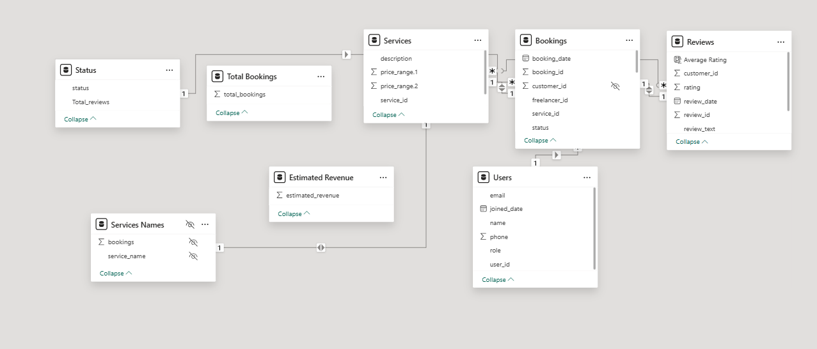

**16. Power BI Dashboard Insights**

Now, let’s align your **Power BI dashboard metrics** with the **database tables**:

### ****1️⃣ Total Users & User Growth****

📌 **Metric:** Count of total users  
📌 **Filter:** Based on role (Customer, Freelancer)  
📌 **Power BI Visualization:** **Card + Line Chart (User Growth Over Time)**

### ****2️⃣ Booking Trends****

📌 **Metric:** Total Bookings per Service  
📌 **Filter:** By time, service name, freelancer  
📌 **Power BI Visualization:** **Bar Chart + Heatmap**

### ****3️⃣ Revenue Insights****

📌 **Metric:** Estimated Revenue by Service  
📌 **Filter:** By month, service type, freelancer  
📌 **Power BI Visualization:** **Stacked Column Chart + KPI Card**

### ****4️⃣ Booking Status Analysis****

📌 **Metric:** Count of bookings by status (Completed, Pending, Canceled)  
📌 **Power BI Visualization:** **Donut Chart + Table View**

### ****5️⃣ Service Performance****

📌 **Metric:** Service popularity (most booked services)  
📌 **Filter:** High vs. low-rated services  
📌 **Power BI Visualization:** **Tree Map + Rating Table**

### ****6️⃣ Review & Rating Analysis****

📌 **Metric:** Average rating per service  
📌 **Filter:** Customer feedback keywords (Positive, Negative)  
📌 **Power BI Visualization:** **Word Cloud + Star Rating Chart**

### ****7️⃣ Daily Revenue & Booking Trends****

📌 **Metric:** Total revenue/bookings per day  
📌 **Power BI Visualization:** **Line Chart + Forecasting**

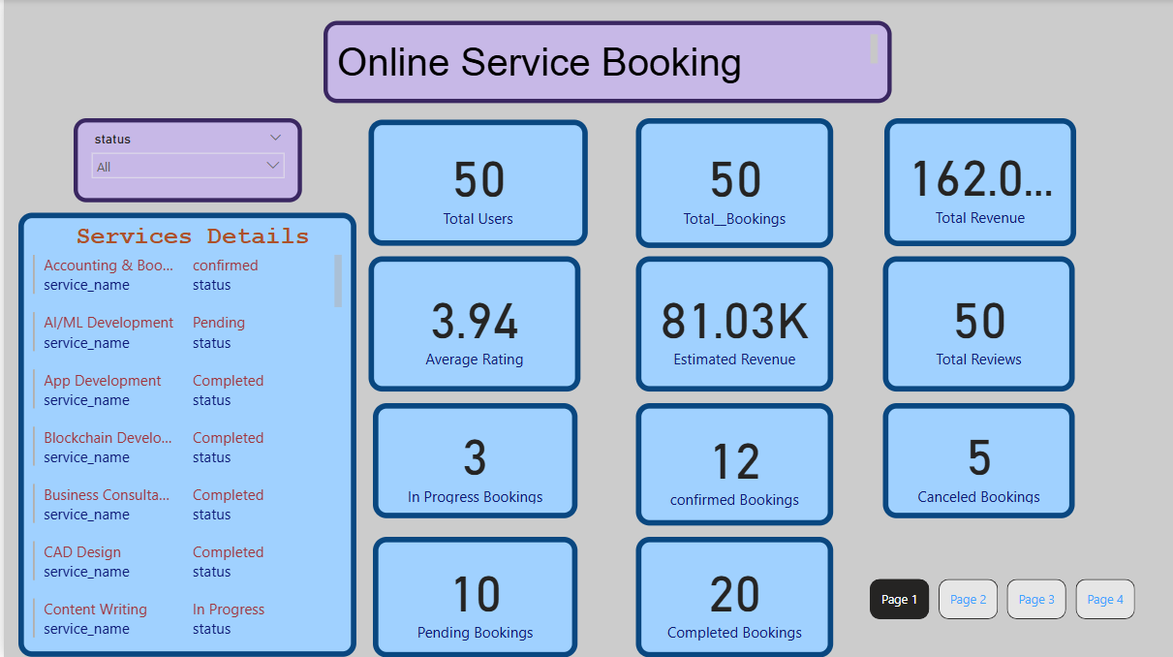

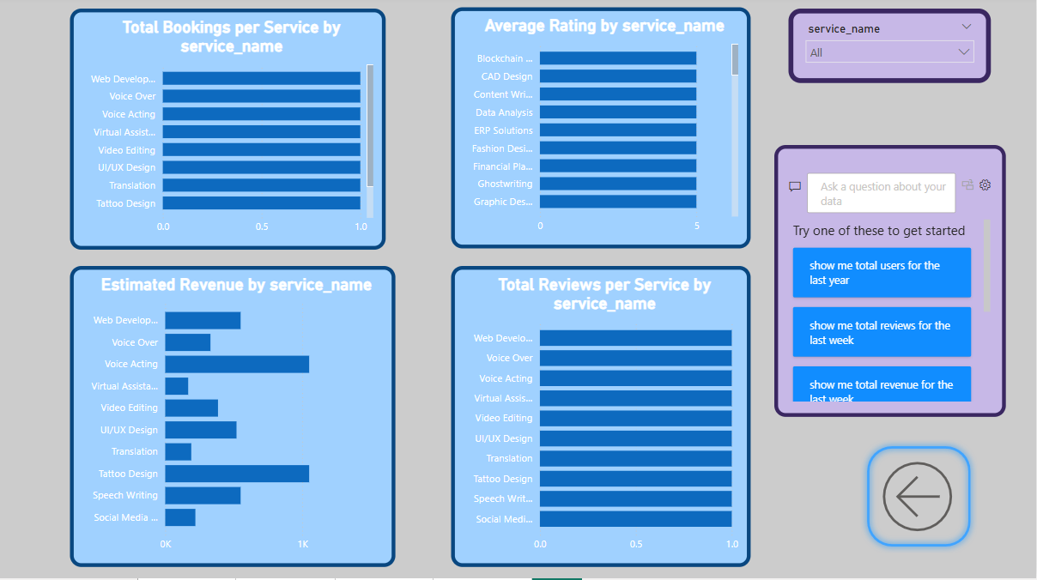

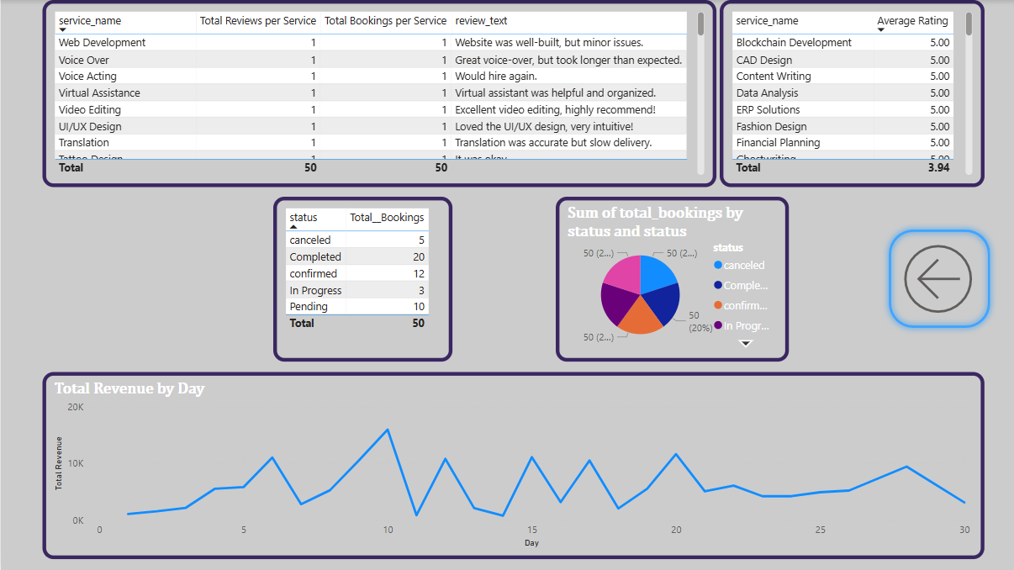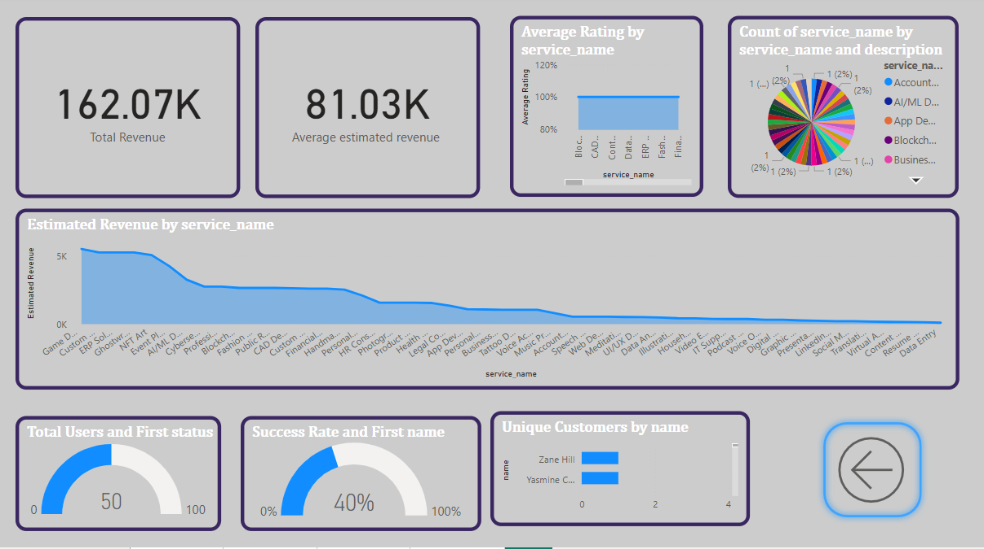

## ****17. Conclusion****

This **comprehensive database-driven analysis** provides valuable insights into **user engagement, revenue trends, and service performance**. By optimizing **pending bookings, improving service quality, and refining pricing strategies**, the platform can achieve **higher customer satisfaction and increased profitability**. 🚀